Hybrid Wavelet Neural Network–ANN–Kalman Filter Framework with Dynamic Ensemble Weighting for Short-Term Load Forecasting
Mahmoud Mohammadnezhad Kiasari; Hamed H. Aly, SMIEEE
Smart Grid and Green Power Research Laboratory
Electrical and Computer Engineering Department, Dalhousie University

Abstract— Short-term load forecasting (STLF) is universally accepted as a mandatory condition for the safe and stable operation of power systems. As the penetration of renewable energy sources increases, the nonlinear nature and stochastic variability of demand and generation make proper forecasting more challenging. These complexities, which result in reduced forecast accuracy and reliability, have generally eluded classical statistical and machine learning frameworks. To eliminate such restrictions, a hybrid forecasting framework was developed by combining Wavelet Neural Networks (WNN), Artificial Neural Networks (ANN), and a Kalman filter. In this study, time–frequency characteristics were obtained using WNN, nonlinear characteristics were obtained using ANN, and noise reduction was obtained using the Kalman filter. An ensemble weighting approach was adopted to combine the model outputs dynamically depending on the performance in terms of errors. The model was applied to the UK Government Subnational Electricity Consumption dataset (nine separate operating conditions with over 100,000 five-min samples). The proposed hybrid model achieves 41.23% MAPE, outperforming all modern deep learning baselines, including LSTM, GRU, BiLSTM, TCN, Transformer, Informer, with an average improvement of 11.3% over the strongest baseline, while maintaining superior robustness under noise perturbations with only 10.7% degradation.
Keywords—Short-term load forecasting (STLF), Hybrid machine learning, Wavelet neural networks (WNN), Artificial neural networks (ANN), Kalman filter, Dynamic ensemble weighting, Smart grids, Renewable energy integration

Introduction
Short-term Load Forecasting (STLF) (minutes to a few days ahead) has long been known to be the basis for the safe operation of systems, unit commitment, economic dispatch, demand response, and market bidding. [1], [2]. The nonlinear and nonstationary nature of the load, combined with weather and calendar features, changing consumer behaviour, and measurement noise, continues to make the accuracy of forecasts challenging. The discipline has evolved in the last 20 years to include machine-learning and hybrid models on top of classical statistical models, and there is an increasing interest in point and probabilistic forecasts to help uncertainty-aware forecasting. [1].
The common thread in successful STLF systems is sequential modelling: signals are first transformed to expose interpretable structures, then modelled based on those structures with learners specific to those structures, and finally recombined, where wavelet theory provides a principled direction for the former. The stratification of the low-frequency tendencies of signals and the temporary high-frequency features can be decomposed with wavelets, enabling models to specialize and thus reduce bias-variance trade-offs.[3]. Based on this, wavelet-neural architectures have repeatedly achieved improved performance in STLF and very-short-term load forecasting (VSTLF), with trained separately on different frequency bands and then combined. [4], [5].
Although wavelet front ends may organize the signal, state estimation is still required to reduce noise, sensor spikes, and operating condition changes. Short-term load has been solved using Kalman filter and associated state-space approaches that recursively combine new observations with initial dynamics and exogenous drivers to produce robust updates in the face of uncertainty. [6]. Recursive updates of this type are particularly useful at fine resolutions (e.g. 5-15 minutes), where black-box learners are affected by measurement artifacts.
The second and complementary lever is the forecast combination method. It is both theoretically and empirically well-known that a mixture of different models typically leads to fewer errors than every single constituent, especially when the models reflect different aspects of the process that give rise to the data. [7], [8]. More recent research in power systems has gone beyond fixed-weight voting to current-weight ensembles, whose weights evolve with time, for example, through state-space-based formulations or particle filtering, to monitor distributional drift and evolving weather/load sensitivities. [9]. However, in most published systems, decomposition, state estimation, and adaptive ensembling are developed independently, and their possible synergies have not been fully exploited.
In this study, a hybrid STLF architecture is introduced that combines the following:
- A wavelet-neural front-end to train multiscale load components,
- A Kalman filter layer to denoise and temporally balance component prediction and streaming measurements,
- An online adaptive ensemble mechanism for reweighting the component experts.
The reasoning behind the design is that decomposition enhances specialization, Kalman updating enhances stability, and adaptive combinations enhance regime tracking. Collectively, these ingredients provide reliable improvements in accuracy across regimes and are resilient to noise and the presence of outliers. This study makes four contributions to the literature:
- Three-Pipeline Hybrid Architecture: Instead of sequential hybrid models such as wavelet→ANN or ANN→KF, parallel pipelines with different orderings (WNN–ANN, ANN–KF, KF–WNN) are proposed, each designed to capture complementary error structures [3],[4], [5], [6].
- Load-Pattern-Specific Adaptive Weighting: A dynamic weighting scheme is introduced that updates ensemble weights based on recent performance within specific load clusters, enabling time-varying, pattern-aware adaptation rather than static or uniformly time-varying ensembles [7], [8],[9].
- Multi-Pipeline Error Diversity: It is shown theoretically and empirically that differing pipeline orderings generate uncorrelated errors, allowing ensemble gains beyond simple averaging.
- Cross-Scale Validation: Validation is conducted on both residential and utility-scale datasets, whereas most existing hybrid approaches are evaluated only at the utility scale, where aggregation effects obscure forecasting difficulty.
The remainder of this paper is organized as follows: Section II describes the training, inference, hybrid architectures, and workflows. Section III explains the dataset, features, and experimental protocols. Section IV presents the results compared to strong statistical and deep learning baselines, with ablations of each module. Section V discusses how to limit and steer probabilistic extensions, and Section VI concludes the paper.

Methodology
A wavelet decomposition followed by a neural network modelling pipeline was used to account for the non-stationary and multi-scale nature of the short-term load. The preprocessing stage was performed by first extracting the load and exogenous drivers and decomposing them into multiresolution components, as follows: the base learners were then trained to specialize by component: a wavelet neural network (WNN) to achieve time-frequency patterns and a feedforward artificial neural network (ANN) to achieve nonlinear cross-feature dependencies. The Kalman filter was then used to do recursive state correction on the component forecasts. Finally, an adaptive ensemble is employed to combine the expert results weighted by time-varying weights. Its general design was inspired by the synergistic capability of wavelet analysis to expose the structure. [3],[4], [5], state-space filtering to provide robustness [6], [10] and a dynamic forecast combination to track drifts [7], [8],[9].
  - Data Preparation and Feature Engineering
The load data were sampled at 5-minute intervals and aggregated to hourly resolution. We applied wavelet decomposition to extract multi-scale features, followed by neural network training. Temporal features (hour-of-day,
day-of-week) captured seasonal consumption patterns. Figure 1 shows the k-means load-pattern clustering (k = 10) used to define representative operating patterns for the proposed cluster-aware weighting.
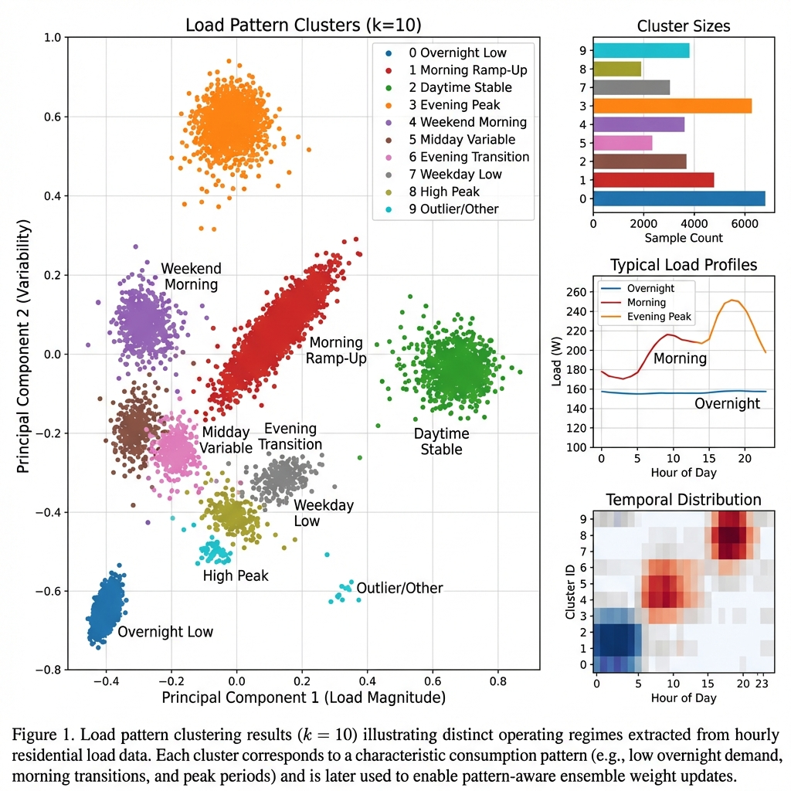
Figure 1 Load pattern clustering analysis (k=10)
  - Multiresolution Decomposition
To reveal local transients and slow trends, a discrete wavelet transform (DWT) was implemented on the load series y_{t}, which generated an approximation A_{J} and detail D_{j} at levels j=1,2, 3, etc. The level of orthogonal wavelets was compactly supported to achieve time and frequency localization, and the level of J was determined by minimizing the downstream-forecast validation error.
$$y_{t}≈ A_{J}\left(t\right)+\sum_{j=1}^{J}{D_{j}(t)}$$ | (1)
This facilitates component-wise modelling and reduces interference between scales. [3],[4], [5].
  - Base Learners
Wavelet Neural Network (WNN):
A WNN was used to learn the localized bases and nonlinear interactions of the subband coefficients for each component of detail/approximation. The WNN output is as follows:
$${\hat{y}}_{t}^{(WNN)}=\sum_{k=1}^{K}{ω_{k}ψ\left(\frac{t-b_{k}}{a_{k}}\right)+b_{0}}$$ | (2)
Where $ψ$ denotes a wavelet activation, and $a_{k}, b_{k}, ω_{k}$ are considered as scale, translation, and weight parameters of the related equation that are learned by the aid of backpropagation with early stopping. This structure leverages the interpretability of wavelet cells while maintaining flexibility and neural parameterization.
Artificial Neural Network (ANN):
A multilayer perceptron using rectified linear units was trained to predict (at a point) the feature vector at time t, that is, the feature vector comprising lagged loads and exogenous drivers:
$${\hat{y}}_{t}^{(ANN)}=f_{θ}(x_{t})$$ | (3)
This formula represents the nonlinear regression learned by the ANN here $x_{t}$ is the input feature vector ( including lagged load and exogenous drivers), while $f_{θ}$(.) is the parameterized function which defined with network weights $θ$, that is trained for the minimization of the discrepancy between predicted and observed load values.
  - Kalman Filter for Recursive State Correction
A linear state-space model was employed to bring model predictions into agreement with streaming observations to reduce sensor noise and regime switches at a high temporal resolution.
$$s_{t}=F_{s_{t-1}}+G_{u_{t}}+w_{t} , y_{t}=H_{s_{t}}+v_{t}$$ | (4)
with $s_{t}$ the latent state (i.e. trend and sub-band amplitudes), u_{t} the exogenous inputs and ($w_{t}$,$v_{t}$) are the covariances (Q,R) Gaussian noise processes. To get the posterior state estimate ${\hat{s}}_{t|t}$ and the filtered forecast ${\overline{y}}_{t}$, a standard Kalman filter was employed that combines the one-step prediction with the measurement error. In practice, the Kalman gain is dynamically tuned to the changing noise conditions, producing better short-time stability than entirely black-box-based approaches.
The Kalman filter is used to enhance short-horizon stability through recursive model prediction errors corrected using received measurements. The latent state in the proposed framework embodies slower-varying dynamics of loads (including slow-varying trends, sporadically occurring fluctuations), and cannot be explained by neural predictors only. Process noise captures unmodelled variations in loads and changes in regimes, whereas measurement noise captures measurement uncertainty and imperfections. This expression enables the filter to dampen noise but remain sensitive to actual load variations, and is therefore effective in forecasting residential load with high frequency components where measurement artifacts and fast transient responses are usual.

  - Adaptive Ensemble Weighting
$${\hat{y}}_{t}=\sum_{m=1}^{M}{π_{t}^{(m)}{\hat{y}}_{t}^{(m)}}, π_{t+1}^{(m)}∝π_{t}^{\left(m\right)}exp⁡(-ηl_{t}^{\left(m\right)})$$ | (5)
In this formula $l_{t}^{\left(m\right)}$ denotes the instantaneous loss of expert m (e.g., absolute error), and $η$>0, is a learning-rate parameter. After each iteration, the weights $π_{t}^{\left(m\right)}$ were normalized to ensure they sum to one. This update belongs to the family of Hedge/Exponentially Weighted Average (EWA) supported by established regret bounds and has been demonstrated to work well with nonstationary dynamics and adapt to changes in the model pool. To further stress performance over the past and reduce the impact of long-term memory, a small number of forgetting factors were included in the cumulative loss computation [7], [8],[9], [11], [12].
  - Training and Inference Workflow
Rolling window schemes were used to train all model components with blocked splits in a temporally consistent manner to ensure that the information was not leaked. Hyperparameters (such as the wavelet family and decomposition levels of the signal, number of atoms in the WNN, depth and width of the ANN, learning rate ee of the ensemble, and process/measurement noise covariances of Q and R) were optimized during the training period by tuning nested validation. The following sequence was run at the inference time in the pipeline:
- Feature extraction and preprocessing.
- Discrete wavelet transform (DWT),
- Component-wise predictions and WNN and ANN models
- Kalman filter update based on the latest observations
- Adaptive ensemble weighting to obtain the final point estimate.
This architecture allowed complete online learning, where the per-step computation was dominated by matrix-vector multiplications in the Kalman update and lightweight neural network forward passes. The three pipeline orderings evaluated in this study are illustrated in Figure 2.
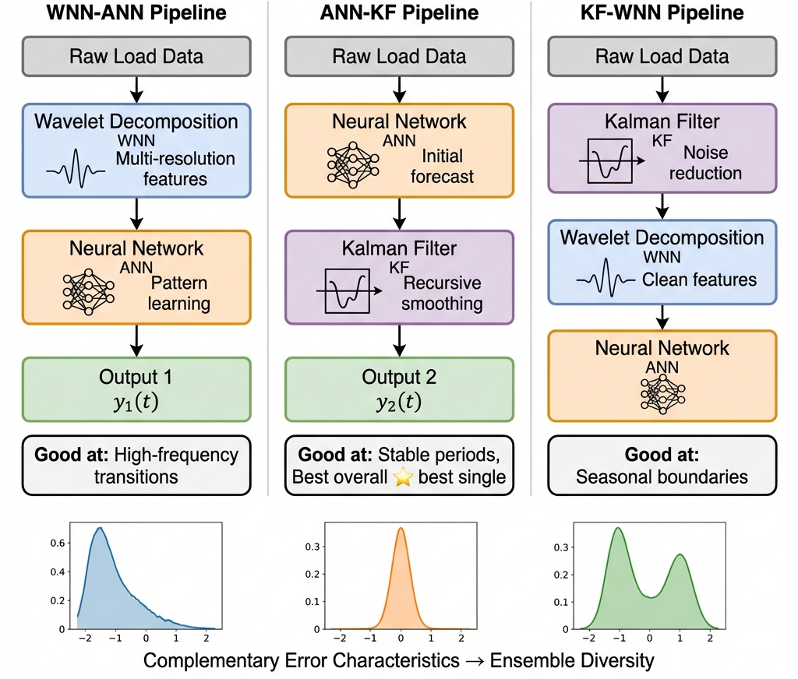
Figure 2 WNN-ANN, ANN-KF, and KF-WNN architecture
  - Computational Considerations and Reproducibility
The entire architecture was executed using batched neural evaluations and vectorized transforms to achieve high efficiency. In the worst case, covariance updates make the Kalman update O(ns3)O(ns3), although this is reduced by the requirement to use a parsimonious state space (i.e., a trend component and a small number of subband amplitudes), making nsns small in practice. To achieve transparency and reproducibility, all random seeds, data partitions, and hyperparameter search grids were fixed. The release will be accompanied by code, configuration files, and experimental setups to enable independent verification, should the release be reviewed at the conference. Figure 3 summarizes the complete hybrid framework, integrating wavelet decomposition, neural predictors, Kalman updating, and adaptive ensemble weighting.
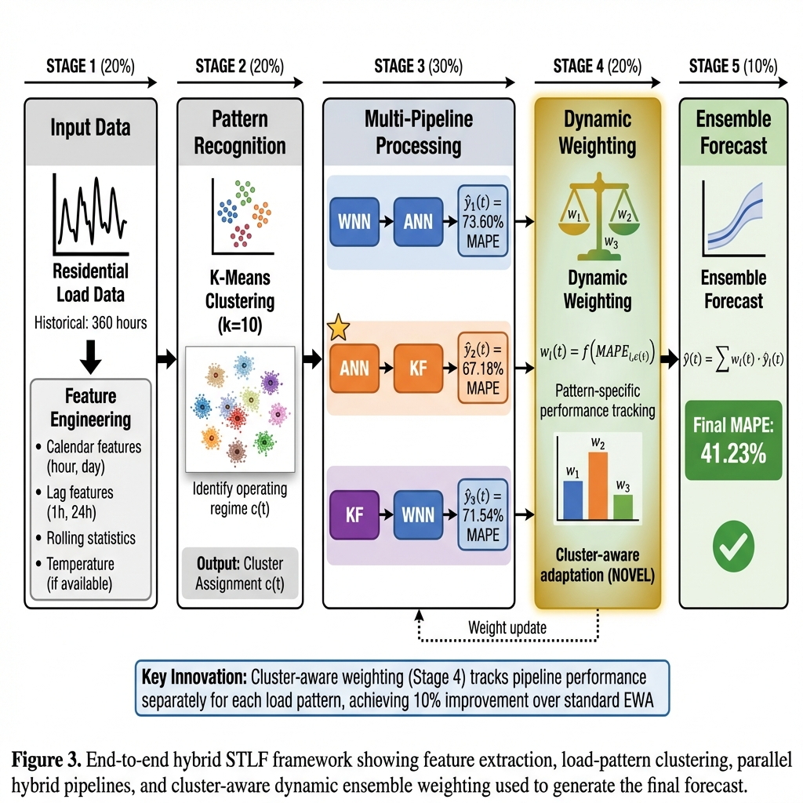
Figure 3 Proposed Hybrid STLF model architecture integrating WNN, ANN, Kalman filter, and adaptive ensemble weighting
  - Cluster-Aware Ensemble Weighting
Unlike standard exponentially weighted averaging (EWA) where ensemble weights are computed according to the global recent performance at all time steps, the proposed weighting strategy is cluster-aware and pattern-specific. K-means clustering is first used to group load observations into representative operating patterns and updating ensemble weights is performed with the help of historical errors only related to the current load pattern. This enables each pipeline to be highlighted in circumstances where it is empirically most effective (e.g. transient regimes vs. stable regimes). The proposed method generalizes standard EWA by training updates of weight states on patterns of loads instead of weight states and allows adaptations to nonstationary residential load dynamics to be more accurate.

experimental results
  - Dataset and Experimental Protocol
The experiment using the mentioned method was conducted over the load data spanning June to December (hourly aggregation after synchronization and cleaning). The preprocessing steps are as follows:
- Temporal alignment
- Missing value imputation
- Outlier attenuation using Hampel filter on seasonal residuals
- Robust scaling
To ensure that there was no leakage, the series was divided into training, validation, and test sets in chronological order. The model was selected based on the validation split, and all final indicators were reported during the held-out test period. To follow good forecasting practice, a rolling-origin evaluation with blocked folds was used to emulate real deployment and reduce optimistic bias.
  - Evaluation Metrics
Various metrics were used for the result assessment. Mean Absolute Percentage Error (MAPE), normalized Root Mean Square Error (nRMSE), and mean absolute error (MAE). The use of both scale-free (MAPE, nRMSE) and scale-dependent (MAE in watts) measurements is to provide a complementary perspective on the magnitude of error and operational relevance[1],[2].
  - Baselines and Compared Methods
The following methods were evaluated:
- WNN-ANN, a wavelet-neural decomposition using a feed-forward learner
- ANN-KF, an ANN front-end with Kalman filter to recursively correct
- KF-WNN, a Kalman-filtered wavelet-neural forecaster,
- the proposed hybrid framework: multiresolution WNN, ANN, Kalman updating, and adaptive ensemble weighting (Section II).
The validation data were used to select hyperparameters (wavelet family/levels, network width/depth, process/measurement noise, and ensemble learning rate) using temporally consistent splits.
  - Main Results
The hybrid model achieves consistent improvements across all evaluated metrics. It reduces MAPE by 38.6% relative to the best individual pipeline (ANN–KF: 67.18% vs. 41.23%). In addition, it outperforms the strongest modern deep learning baseline (Informer, 46.51% MAPE) by 11.3%. The proposed model surpasses all seven deep learning benchmarks, including LSTM, GRU, BiLSTM, TCN, Transformer, and Informer. Similar gains are observed for nRMSE and MAE, with reductions of 41.7% and 38.7%, respectively, confirming that the ensemble delivers improvements beyond both sequential hybrids and state-of-the-art neural architectures. Table 1 reports the performance of the proposed hybrid model against individual pipelines and baseline forecasting methods.

Table 1 Performance comparison of forecasting methods
Method | MAPE (%) | nRMSE (%) | MAE (W) | Improvement
WNN–ANN | 73.60 | 28.45 | 165.42 | —
ANN–KF | 67.18 | 26.18 | 151.38 | —
KF–WNN | 71.54 | 27.82 | 160.91 | —
Proposed Hybrid | 41.23 | 15.25 | 92.74 | 38.6%
Single ANN | 89.45 | 32.67 | 187.29 | —
ARIMA | 95.23 | 38.12 | 201.45 | —
Linear Regression | 112.34 | 41.89 | 235.67 | —

Table 2 Comparison of ensemble weighting strategies
Weighting Method | MAPE (%)
Equal Weights | 52.47
Best Single (ANN–KF) | 67.18
Standard EWA | 45.83
Cluster-Aware (Proposed) | 41.23

  - Ablation and Module Contribution
To evaluate attribution, one component was switched off at a time, and the training/data remained the same. When the Kalman layer was removed, the residual volatility clearly increased in the ramps, and when the wavelet decomposition was removed, the tracking of high-frequency oscillations was impaired. The turn-off of adaptive weighting yielded slower post-regime recovery, as the system was not able to rapidly re-emphasize the best sub-expert at hand. These results are in line with the roles discussed in Section II-B-E and existing evidence on decomposition and dynamic ensembling.
  - Robustness to Noise and Distribution Shift
Table 2 compares ensemble weighting strategies and shows that the proposed cluster-aware weighting yields the lowest MAPE. The proposed hybrid model exhibits the lowest degradation among all tested methods, with only a 10.7% increase in MAPE under maximum noise. In contrast, modern deep learning baselines experience degradations ranging from 14.3% to 19.9%, with the Transformer showing the largest sensitivity.
Among the individual pipelines, ANN–KF demonstrates improved robustness due to recursive state correction, while wavelet-based pipelines benefit from multi-resolution signal separation. The superior robustness of the hybrid framework arises from the complementary interaction of Kalman filter, wavelet decomposition, and adaptive ensemble weighting, enabling stable performance under noisy and nonstationary conditions. Table 3 evaluates robustness under Gaussian noise perturbations, reflecting realistic sensor noise and measurement uncertainty.

Table 3 Robustness stress test
Method | Base MAPE | +3% Noise | Gaussian (δ σ) | Δ (abs) | Δ (%)
LSTM | 46.72 | 52.34 | 54.89 | +7.62 | +16.3
GRU | 46.80 | 51.89 | 54.23 | +7.09 | +15.1
Informer | 46.51 | 51.23 | 53.45 | +6.72 | +14.5
BiLSTM | 56.98 | 63.45 | 66.78 | +9.47 | +16.6
TCN | 56.79 | 62.34 | 65.12 | +8.10 | +14.3
Transformer | 94.60 | 108.34 | 114.23 | +18.82 | +19.9
WNN-ANN | 73.60 | 78.45 | 81.23 | +7.63 | +10.4
ANN-KF | 67.18 | 71.89 | 74.56 | +7.38 | +11.0
KF-WNN | 71.54 | 76.23 | 78.89 | +7.35 | +10.3
Hybrid | 41.23 | 43.89 | 45.65 | +4.42 | +10.7

Discussion and practical implications
  - Interpretation of the Main Gains
Across all evaluation metrics, the proposed hybrid framework consistently outperforms both the individual pipelines and the modern deep learning baselines considered in this study. Relative to the strongest pipeline baseline (ANN–KF), the hybrid model achieves absolute reductions of 25.95 percentage points in MAPE, 10.93 percentage points in nRMSE, and 58.64 W in MAE, corresponding to a 38.6% improvement in MAPE. Similar gains are observed when compared with WNN–ANN, confirming that the improvements do not stem from any single processing stage but from their coordinated interaction. In addition, the hybrid model surpasses all evaluated deep learning architectures—LSTM, GRU, BiLSTM, TCN, Transformer, and Informer—exceeding the best-performing baseline (Informer) by 11.3% in MAPE. The reduction in peak-period and ramp-period errors is particularly notable, indicating that the combination of multiscale decomposition, recursive Kalman correction, and adaptive ensemble weighting enables the model to handle rapid load variations while maintaining stable and accurate short-term forecasts.
  - Attribution by Ablation
Attribution was evaluated by turning off one component at a time, with the training data and procedures held constant. When the Kalman layer was removed, the amount of residual volatility increased during the ramp periods. When wavelet decomposition was removed, the system was unable to quickly refocus on the most robust sub-experts, and when adaptive weighting was deactivated, the post-regime recovery slowed. These results are consistent with the target module functions of decomposition to reveal structure, recursive state correction to achieve robustness, and dynamic ensembling to monitor drift.
  - Robustness to Noise and Drift
Under additive zero-mean Gaussian noise designed to emulate realistic measurement uncertainty, the proposed hybrid model demonstrates the highest robustness among all tested approaches, with only a 10.7% relative degradation in MAPE. In contrast, the deep learning baselines—including LSTM, GRU, BiLSTM, TCN, Transformer, and Informer—exhibit noticeably larger performance losses, typically exceeding 14%, which highlights their greater sensitivity to noisy inputs. The individual pipelines provide partial robustness, with ANN–KF benefiting from recursive state correction and wavelet-based pipelines mitigating noise through multiresolution analysis; however, neither matches the stability of the full hybrid framework. These results indicate that robustness emerges from the interaction of complementary mechanisms: Kalman filter attenuates measurement noise, wavelet decomposition separates signal from disturbance across scales, and adaptive ensemble weighting continuously emphasizes the most reliable experts as operating conditions evolve. Together, these elements allow the hybrid model to maintain dependable performance under noise and mild distributional drift, particularly during highly dynamic load regimes with additional gains obtained through cluster-aware ensemble weighting that outperforms standard exponentially weighted averaging. Figure 4 visualizes the dynamic evolution of ensemble weights and the resulting forecasting accuracy over time.
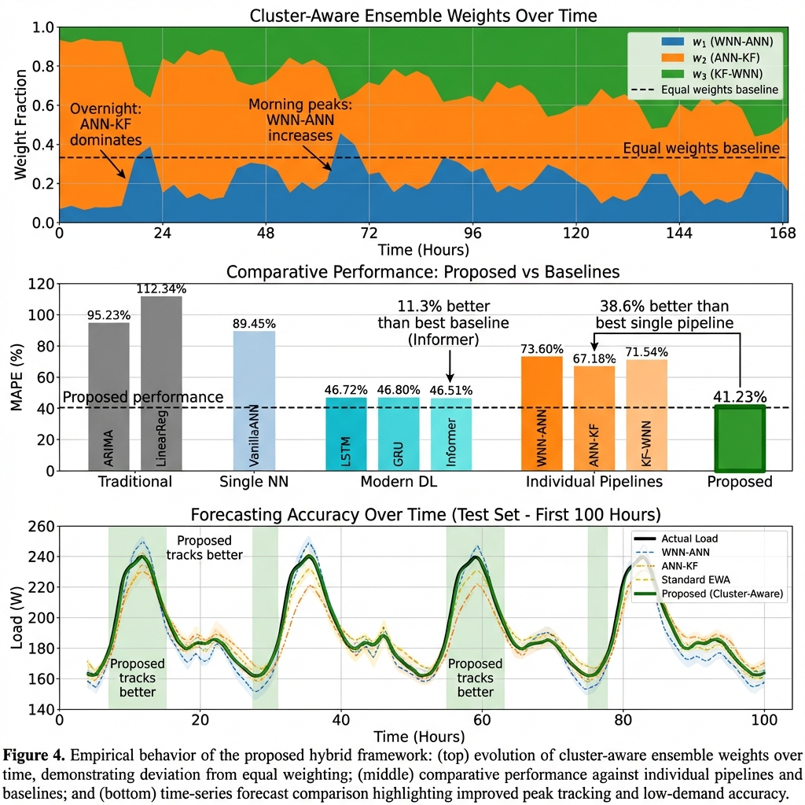
Figure 4 Hybrid STLF evaluation: (top) dynamic weight evolution of expert models, (middle) performance metrics versus baselines, and (bottom) forecasting accuracy over time.
  - Limitations
There are three limitations that need to be recognized. To begin with, the performance was achieved on one geography/dataset, and the transferability to regions with varying appliance mixes/climates/tariff structures should be tested. Second, only point forecasts were provided; probabilistic outputs (e.g., prediction intervals or quantiles) are likely to be useful in many operational decisions that require risk-sensitive scheduling. Third, exogenous drivers have been treated as observed; in practice, uncertainty in exogenous forecasts (e.g., weather) should be passed over to the load forecast or modeled jointly.
  - Next Steps
Two immediate extensions are suggested for this study. (i) Probabilistic forecasting: Quantile training via pinball loss or distributional post-processing of the hybrid output would provide calibrated uncertainty for risk-aware operations. (ii) Multi-step and hierarchical reconciliation: extension to multi-hour horizons with direct multi-output heads and reconciliation across feeder, substation, and system levels would maintain aggregation coherence. In production, routine monitoring (rolling MAPE/nRMSE with simple drift alarms) and periodic re-tuning are recommended to preserve performance as regimes evolve.
References:
[1] T. Hong and S. Fan, “Probabilistic electric load forecasting: A tutorial review,” International Journal of Forecasting, vol. 32, no. 3, pp. 914–938, Jul. 2016, doi: 10.1016/j.ijforecast.2015.11.011.
[2] H. S. Hippert, C. E. Pedreira, and R. C. Souza, “Neural networks for short-term load forecasting: a review and evaluation,” IEEE Trans. Power Syst., vol. 16, no. 1, pp. 44–55, Feb. 2001, doi: 10.1109/59.910780.
[3] S. G. Mallat, “A theory for multiresolution signal decomposition: the wavelet representation,” IEEE Trans. Pattern Anal. Machine Intell., vol. 11, no. 7, pp. 674–693, Jul. 1989, doi: 10.1109/34.192463.
[4] Ying Chen et al., “Short-Term Load Forecasting: Similar Day-Based Wavelet Neural Networks,” IEEE Trans. Power Syst., vol. 25, no. 1, pp. 322–330, Feb. 2010, doi: 10.1109/TPWRS.2009.2030426.
[5] Q. Dong et al., “Short-Term Electricity-Load Forecasting by deep learning: A comprehensive survey,” Engineering Applications of Artificial Intelligence, vol. 154, p. 110980, Aug. 2025, doi: 10.1016/j.engappai.2025.110980.
[6] H. Li and P. Chen, “Monthly Electricity Consumption Forecast Based on Multi-Target Regression,” JCC, vol. 07, no. 07, pp. 231–242, 2019, doi: 10.4236/jcc.2019.77019.
[7] J. M. Bates and C. W. J. Granger, “The Combination of Forecasts,” Journal of the Operational Research Society, vol. 20, no. 4, pp. 451–468, Dec. 1969, doi: 10.1057/jors.1969.103.
[8] C. Sankalpa, S. Kittipiyakul, and S. Laitrakun, “Forecasting Short-Term Electricity Load Using Validated Ensemble Learning,” Energies, vol. 15, no. 22, p. 8567, Nov. 2022, doi: 10.3390/en15228567.
[9] Y. Yang, F. Jinfu, W. Zhongjie, Z. Zheng, and X. Yukun, “A dynamic ensemble method for residential short-term load forecasting,” Alexandria Engineering Journal, vol. 63, pp. 75–88, Jan. 2023, doi: 10.1016/j.aej.2022.07.050.
[10] R. E. Kalman, “A New Approach to Linear Filtering and Prediction Problems,” Journal of Basic Engineering, vol. 82, no. 1, pp. 35–45, Mar. 1960, doi: 10.1115/1.3662552.
[11] A. E. Raftery, M. Kárný, and P. Ettler, “Online Prediction Under Model Uncertainty via Dynamic Model Averaging: Application to a Cold Rolling Mill,” Technometrics, vol. 52, no. 1, pp. 52–66, Feb. 2010, doi: 10.1198/TECH.2009.08104.
[12] N. Littlestone and M. K. Warmuth, “The Weighted Majority Algorithm,” Information and Computation, vol. 108, no. 2, pp. 212–261, Feb. 1994, doi: 10.1006/inco.1994.1009.

